EE3315 Lab 1 – 3.2.1.9 Configuring Basic RIPv2
- Sem B 2021/2022 PT
Topology
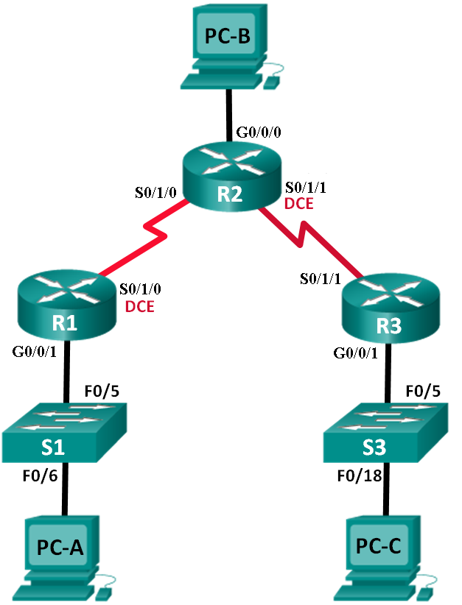
Addressing Table
Device | Interface | IP Address | Subnet Mask | Default Gateway
R1 | G0/0/1 | 172.16.10.1 | 255.255.255.0 | N/A
 | S0/1/0 (DCE) | 10.1.1.1 | 255.255.255.252 | N/A
R2 | G0/0/0 | 209.165.200.1 | 255.255.255.0 | N/A
 | S0/1/0 | 10.1.1.2 | 255.255.255.252 | N/A
 | S0/1/1 (DCE) | 10.2.2.2 | 255.255.255.252 | N/A
R3 | G0/0/1 | 172.16.30.1 | 255.255.255.0 | N/A
 | S0/1/1 | 10.2.2.1 | 255.255.255.252 | N/A
S1 | N/A | VLAN 1 | N/A | N/A
S3 | N/A | VLAN 1 | N/A | N/A
PC-A | NIC | 172.16.10.3 | 255.255.255.0 | 172.16.10.1
PC-B | NIC | 209.165.200.2 | 255.255.255.0 | 209.165.200.1
PC-C | NIC | 172.16.30.3 | 255.255.255.0 | 172.16.30.1
Objectives
Part 1: Build the Network and Configure Basic Device Settings
Part 2: Configure and Verify RIPv2 Routing
- Configure RIPv2 on the routers and verify that it is running.
- Configure a passive interface.
- Examine routing tables.
- Disable automatic summarization.
- Configure a default route.
- Verify end-to-end connectivity.
Background / Scenario
RIP version 2 (RIPv2) is used for routing of IPv4 addresses in small networks. RIPv2 is a classless, distance-vector routing protocol. Because RIPv2 is a classless routing protocol, subnet masks are included in the routing updates. By default, RIPv2 automatically summarizes networks at major network boundaries. When automatic summarization has been disabled, RIPv2 no longer summarizes networks to their classful address at boundary routers.
In this lab, you will configure the network topology with RIPv2 routing, disable automatic summarization, propagate a default route, and use CLI commands to display and verify RIP routing information.

- Build the Network and Configure Basic Device Settings
In Part 1, you will set up the network topology and configure basic settings.

Open the template : lab1_rip_template.pkt with the program Packet Tracer.
** The video file EE3315_lab1.mp4 is for reference only, please follow the lab sheet.
  - Cable the network as shown in the topology.
  - Configure basic settings for each router and switch.
    - Configure device names as shown in the topology.
    - Configure the IP addresses listed in the Addressing Table for all interfaces.
    - Configure a description for each interface with an IP address.
    - Configure the clock rate, if applicable, to the DCE serial interface.
    - Copy the running-configuration to the startup-configuration.
  - Configure PC IP Addressing.
Refer to the Addressing Table for IP address information of the PCs.
  - Test connectivity.
At this point, the PCs are unable to ping each other.
    - Each workstation should be able to ping the attached router. Verify and troubleshoot if necessary.
    - The routers should be able to ping one another. Verify and troubleshoot if necessary.
- Configure and Verify RIPv2 Routing
In Part 2, you will configure RIPv2 routing on all routers in the network and then verify that the routing tables are updated correctly. After RIPv2 has been verified, you will disable automatic summarization, configure a default route, and verify end-to-end connectivity.
  - Configure RIPv2 routing.
    - Configure RIPv2 on R1as the routing protocol and advertise the appropriate connected networks.
R1# config t
R1(config)# router rip
R1(config-router)# version 2
R1(config-router)# passive-interface g0/0/1
R1(config-router)# network 172.16.0.0
R1(config-router)# network 10.0.0.0
The passive-interface command stops routing updates out the specified interface. This process prevents unnecessary routing traffic on the LAN. However, the network that the specified interface belongs to is still advertised in routing updates that are sent out across other interfaces.
    - Configure RIPv2 on R3 and use the network statement to add the appropriate connected networks and prevent routing updates on the LAN interface.
    - Configure RIPv2 on R2 and use the network statements to add the appropriate connected networks. Do not advertise the 209.165.200.0 network.
Note: It is not necessary to make the G0/0/0 interface passive on R2 because the network associated with this interface is not being advertised.
  - Examine the current state of the network.
    - The status of the two serial links can quickly be verified using the show ip interface brief command on R2.
R2# show ip interface brief
Interface IP-Address OK? Method Status Protocol
GigabitEthernet0/0/0 209.165.200.1 YES manual up up
GigabitEthernet0/0/1 unassigned YES unset administratively down down
Serial0/1/0 10.1.1.2 YES manual up up
Serial0/1/1 10.2.2.2 YES manual up up
    - Check connectivity between PCs.
From PC-A, is it possible to ping PC-B? _________ Why?
____________________________________________________________________________________
From PC-A, is it possible to ping PC-C? _________ Why?
____________________________________________________________________________________
From PC-C, is it possible to ping PC-B? _________ Why?
____________________________________________________________________________________
From PC-C, is it possible to ping PC-A? _________ Why?
____________________________________________________________________________________
    - Verify that RIPv2 is running on the routers.
You can use the debug ip rip, show ip protocols, and show run commands to confirm that RIPv2 is running. The show ip protocols command output for R1 is shown below.
R1# show ip protocols
Routing Protocol is "rip"
Outgoing update filter list for all interfaces is not set
Incoming update filter list for all interfaces is not set
Sending updates every 30 seconds, next due in 7 seconds
Invalid after 180 seconds, hold down 180, flushed after 240
Redistributing: rip
Default version control: send version 2, receive 2
Interface Send Recv Triggered RIP Key-chain
Serial0/1/0 2 2
Automatic network summarization is in effect
Maximum path: 4
Routing for Networks:
10.0.0.0
172.16.0.0
Passive Interface(s):
GigabitEthernet0/0/1
Routing Information Sources:
Gateway Distance Last Update
10.1.1.2 120
Distance: (default is 120)
When issuing the debug ip rip command on R2, what information is provided that confirms RIPv2 is running?
____________________________________________________________________________________
When you are finished observing the debugging outputs, issue the undebug all command at the privileged EXEC prompt.
When issuing the show run command on R3, what information is provided that confirms RIPv2 is running?
____________________________________________________________________________________
____________________________________________________________________________________
    - Examine the automatic summarization of routes.
The LANs connected to R1 and R3 are composed of discontiguous networks. R2 displays two equal-cost paths to the 172.16.0.0/16 network in the routing table. R2 displays only the major classful network address of 172.16.0.0 and does not display any of the subnets for this network.
R2# show ip route
<Output omitted>
10.0.0.0/8 is variably subnetted, 4 subnets, 2 masks
C 10.1.1.0/30 is directly connected, Serial0/1/0
L 10.1.1.2/32 is directly connected, Serial0/1/0
C 10.2.2.0/30 is directly connected, Serial0/1/1
L 10.2.2.2/32 is directly connected, Serial0/1/1
R 172.16.0.0/16 [120/1] via 10.2.2.1, 00:00:23, Serial0/1/1
[120/1] via 10.1.1.1, 00:00:09, Serial0/1/0
209.165.200.0/24 is variably subnetted, 2 subnets, 2 masks
C 209.165.200.0/24 is directly connected, GigabitEthernet0/0/0
L 209.165.200.1/32 is directly connected, GigabitEthernet0/0/0
R1 displays only its own subnet for the 172.16.10.0/24 network. R1 does not have a route for the 172.16.30.0/24 subnet on R3.
R1# show ip route
<Output omitted>
10.0.0.0/8 is variably subnetted, 3 subnets, 2 masks
C 10.1.1.0/30 is directly connected, Serial0/1/0
L 10.1.1.1/32 is directly connected, Serial0/1/0
R 10.2.2.0/30 [120/1] via 10.1.1.2, 00:00:21, Serial0/1/0
172.16.0.0/16 is variably subnetted, 2 subnets, 2 masks
C 172.16.10.0/24 is directly connected, GigabitEthernet0/0/1
L 172.16.10.1/32 is directly connected, GigabitEthernet0/0/1
R3 only displays its own subnet for the 172.16.30.0/24 network. R3 does not have a route for the 172.16.10.0/24 subnets on R1.
R3# show ip route
<Output omitted>
10.0.0.0/8 is variably subnetted, 3 subnets, 2 masks
C 10.2.2.0/30 is directly connected, Serial0/1/1
L 10.2.2.1/32 is directly connected, Serial0/1/1
R 10.1.1.0/30 [120/1] via 10.2.2.2, 00:00:23, Serial0/1/1
172.16.0.0/16 is variably subnetted, 2 subnets, 2 masks
C 172.16.30.0/24 is directly connected, GigabitEthernet0/0/1
L 172.16.30.1/32 is directly connected, GigabitEthernet0/0/1
Use the debug ip rip command on R2 to determine the routes received in the RIP updates from R3 and list them here.
________________________________________________________________________________
R3 is not sending any of the 172.16.0.0 subnets, only the summarized route of 172.16.0.0/16, including the subnet mask. Therefore, the routing tables on R1 and R2 do not display the 172.16.0.0 subnets on R3.
  - Disable automatic summarization.
    - The no auto-summary command is used to turn off automatic summarization in RIPv2. Disable auto summarization on all routers. The routers will no longer summarize routes at major classful network boundaries. R1 is shown here as an example.
R1(config)# router rip
R1(config-router)# no auto-summary
    - Issue the clear ip route * command to clear the routing table.
R1(config-router)# end
R1# clear ip route *
    - Examine the routing tables. Remember that it will take some time to converge the routing tables after clearing them.
The LAN subnets connected to R1 and R3 should now be included in all three routing tables.
R2# show ip route
<Output omitted>
Gateway of last resort is not set

10.0.0.0/8 is variably subnetted, 4 subnets, 2 masks
C 10.1.1.0/30 is directly connected, Serial0/1/0
L 10.1.1.2/32 is directly connected, Serial0/1/0
C 10.2.2.0/30 is directly connected, Serial0/1/1
L 10.2.2.2/32 is directly connected, Serial0/1/1
172.16.0.0/16 is variably subnetted, 3 subnets, 2 masks
R 172.16.0.0/16 [120/1] via 10.2.2.1, 00:01:01, Serial0/1/1
[120/1] via 10.1.1.1, 00:01:15, Serial0/1/0
R 172.16.10.0/24 [120/1] via 10.1.1.1, 00:00:21, Serial0/1/0
R 172.16.30.0/24 [120/1] via 10.2.2.1, 00:00:04, Serial0/1/1
209.165.200.0/24 is variably subnetted, 2 subnets, 2 masks
C 209.165.200.0/24 is directly connected, GigabitEthernet0/0/0
L 209.165.200.1/32 is directly connected, GigabitEthernet0/0/0
R1# show ip route
<Output omitted>
Gateway of last resort is not set

10.0.0.0/8 is variably subnetted, 3 subnets, 2 masks
C 10.1.1.0/30 is directly connected, Serial0/1/0
L 10.1.1.1/32 is directly connected, Serial0/1/0
R 10.2.2.0/30 [120/1] via 10.1.1.2, 00:00:12, Serial0/1/0
172.16.0.0/16 is variably subnetted, 3 subnets, 2 masks
C 172.16.10.0/24 is directly connected, GigabitEthernet0/0/1
L 172.16.10.1/32 is directly connected, GigabitEthernet0/0/1
R 172.16.30.0/24 [120/2] via 10.1.1.2, 00:00:12, Serial0/1/0
R3# show ip route
<Output omitted>
10.0.0.0/8 is variably subnetted, 3 subnets, 2 masks
C 10.2.2.0/30 is directly connected, Serial0/1/1
L 10.2.2.1/32 is directly connected, Serial0/1/1
R 10.1.1.0/30 [120/1] via 10.2.2.2, 00:00:23, Serial0/1/1
172.16.0.0/16 is variably subnetted, 2 subnets, 2 masks
C 172.16.30.0/24 is directly connected, GigabitEthernet0/0/1
L 172.16.30.1/32 is directly connected, GigabitEthernet0/0/1
R 172.16.10.0 [120/2] via 10.2.2.2, 00:00:16, Serial0/1/1
    - Use the debug ip rip command on R2 to examine the RIP updates.
R2# debug ip rip
After 60 seconds, issue the no debug ip rip command.
What routes are in the RIP updates that are received from R3?
________________________________________________________________________________
Are the subnet masks included in the routing updates? _________
  - Configure and redistribute a default route for Internet access.
    - From R2, create a static route to network 0.0.0.0 0.0.0.0, using the ip route command. This forwards any traffic with an unknown destination address to PC-B at 209.165.200.2, simulating the Internet by setting a Gateway of Last Resort on router R2.
R2(config)# ip route 0.0.0.0 0.0.0.0 209.165.200.2
    - R2 will advertise a route to the other routers if the default-information originate command is added to its RIP configuration.
R2(config)# router rip
R2(config-router)# default-information originate
  - Verify the routing configuration.
    - View the routing table on R1.
R1# show ip route
<Output omitted>
Gateway of last resort is 10.1.1.2 to network 0.0.0.0

R* 0.0.0.0/0 [120/1] via 10.1.1.2, 00:00:13, Serial0/1/0
10.0.0.0/8 is variably subnetted, 3 subnets, 2 masks
C 10.1.1.0/30 is directly connected, Serial0/1/0
L 10.1.1.1/32 is directly connected, Serial0/1/0
R 10.2.2.0/30 [120/1] via 10.1.1.2, 00:00:13, Serial0/1/0
172.16.0.0/16 is variably subnetted, 3 subnets, 2 masks
C 172.16.10.0/24 is directly connected, GigabitEthernet0/0/1
L 172.16.10.1/32 is directly connected, GigabitEthernet0/0/1
R 172.16.30.0/24 [120/2] via 10.1.1.2, 00:00:13, Serial0/1/0
How can you tell from the routing table that the subnetted network shared by R1 and R3 has a pathway for Internet traffic?
____________________________________________________________________________________
____________________________________________________________________________________
    - View the routing table on R2.
How is the pathway for Internet traffic provided in its routing table?
____________________________________________________________________________________
____________________________________________________________________________________
  - Verify connectivity.
    - Simulate sending traffic to the Internet by pinging from PC-A and PC-C to 209.165.200.2.
The ping should be successful. If not, troubleshoot.
    - Verify that hosts within the subnetted network can reach each other by pinging between PC-A and PC-C.
The ping should be successful. If not, troubleshoot.

** Save the Packet Tracer file (.pkt) and upload to Canvas.
** Fill in the answers and submit the lab sheet (.docx) to Canvas. Remember to zip the two files.

Reflection
  - Why would you turn off automatic summarization for RIPv2?
_______________________________________________________________________________________

  - How did R1 and R3 learn the pathway to the Internet?
_______________________________________________________________________________________

